# **Deploy from GitHub**

In this exercise, you will deploy a sample ASP.NET application to your Web App from a GitHub repository.

## **Task 1: Fork the LiveTrainingTestApp GitHub Repository**

The ASP.NET app you will deploy is in my LiveTrainingTestApp GitHub repository. In order to deploy it, you need to create your own copy of this repository in your GitHub account. You’ll do that by forking my repository.

1. Browse to https://github.com and log in using your GitHub credentials.
2. Browse to my GitHub repository at https://github.com/jamesche75/LiveTrainingTestApp.
3. Click on **Fork** to create your own copy of the repository.

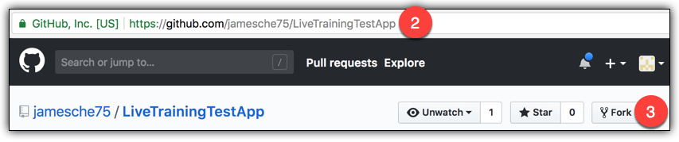

It will take a few seconds to fork the repository. Once it has been successfully forked, you’ll see a copy of it in your GitHub account.

## **Task 2: Configure Deployment Options in the Web App**

App Service makes it easy to set up continuous deployment from GitHub. Once you connect your Web App to the GitHub repository, each time you push new changes to the repository, your Web App will automatically pick them up.

1. Browse to the Azure portal at https://portal.azure.com and log in if necessary.
2. Open the Web App you created in the first exercise.
3. In the menu, click **Deployment Options**.

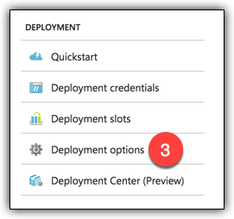

1. Click **Configure Required Settings** under Choose Source.

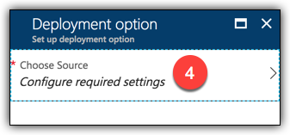

1. Click **GitHub** to set up a deployment from GitHub.

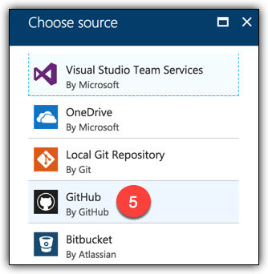

1. Click **Configure Required Settings** to log into your GitHub account and authorize the Azure portal to access your repositories. (If you have already authorized the Azure portal, you will see your GitHub account name here. In that case, skip to Step 10.)

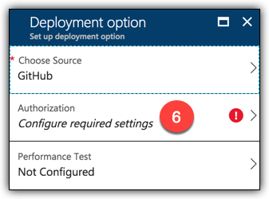

1. Click **Authorize** to authorize Azure to access your account. (You may be prompted to login to your GitHub account.)

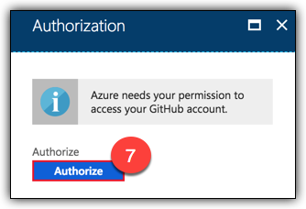

1. Click **Authorize Azure** to complete the authorization process.

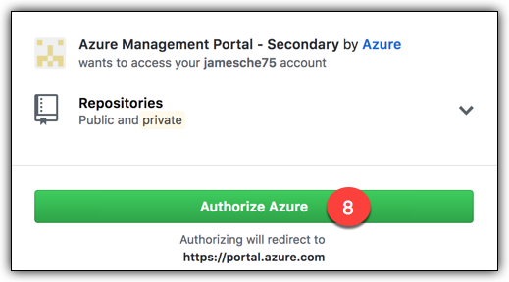

1. Click **OK** to confirm and continue.

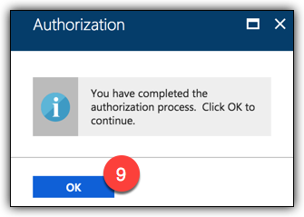

1. Click **Configure Required Settings** under Choose Project to choose your GitHub project.

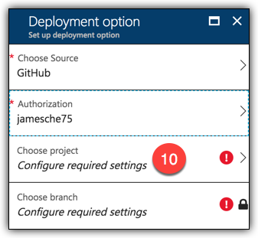

1. Click **LiveTrainingTestApp** to select it as the project.

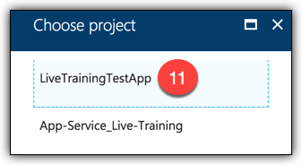

Since you only have one branch in this repository (the Master branch), it’s selected for you automatically.

1. Click **OK** to create your deployment.

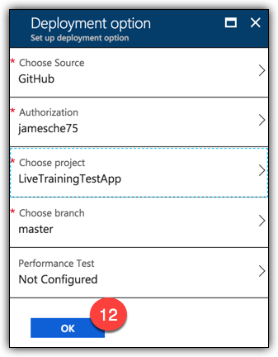

It will take a few seconds for Azure to configure source control. Once it succeeds, you’ll see a notification like the one below.

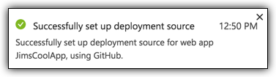

You can view the status of your deployment by clicking **Deployment Options** again. When you do, you’ll see something similar to the figure below. (If you see “No deployments found,” wait a few seconds and it should update automatically.)

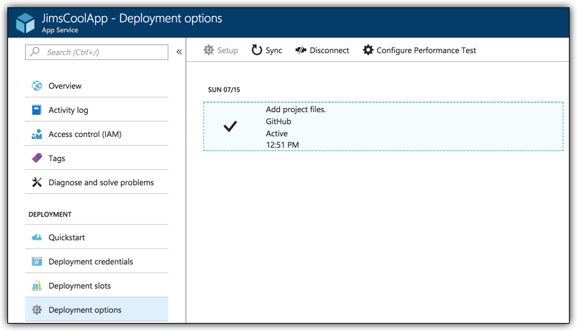

If a deployment fails, you’ll see a failure notice here and you can click on it to see the log of the failure.

## **Task 3: Testing the Deployment**

Once your deployment succeeds and it shows a status of **Active** as shown in the figure above, you are ready to test it.

1. Browse to your Web App in a browser. As a shortcut, you can just click on **Browse** in the Overview blade in the Azure portal.

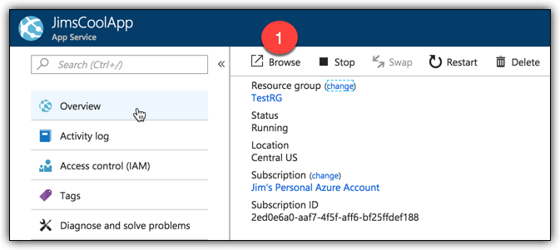

When your Web App comes up, you should see a page that looks like the figure below.

